Version Control

Samuel Cooke – s251388

Repository Link
Link: https://github.com/s251388/AIE-2.1.5-Switch.git
Screenshot:
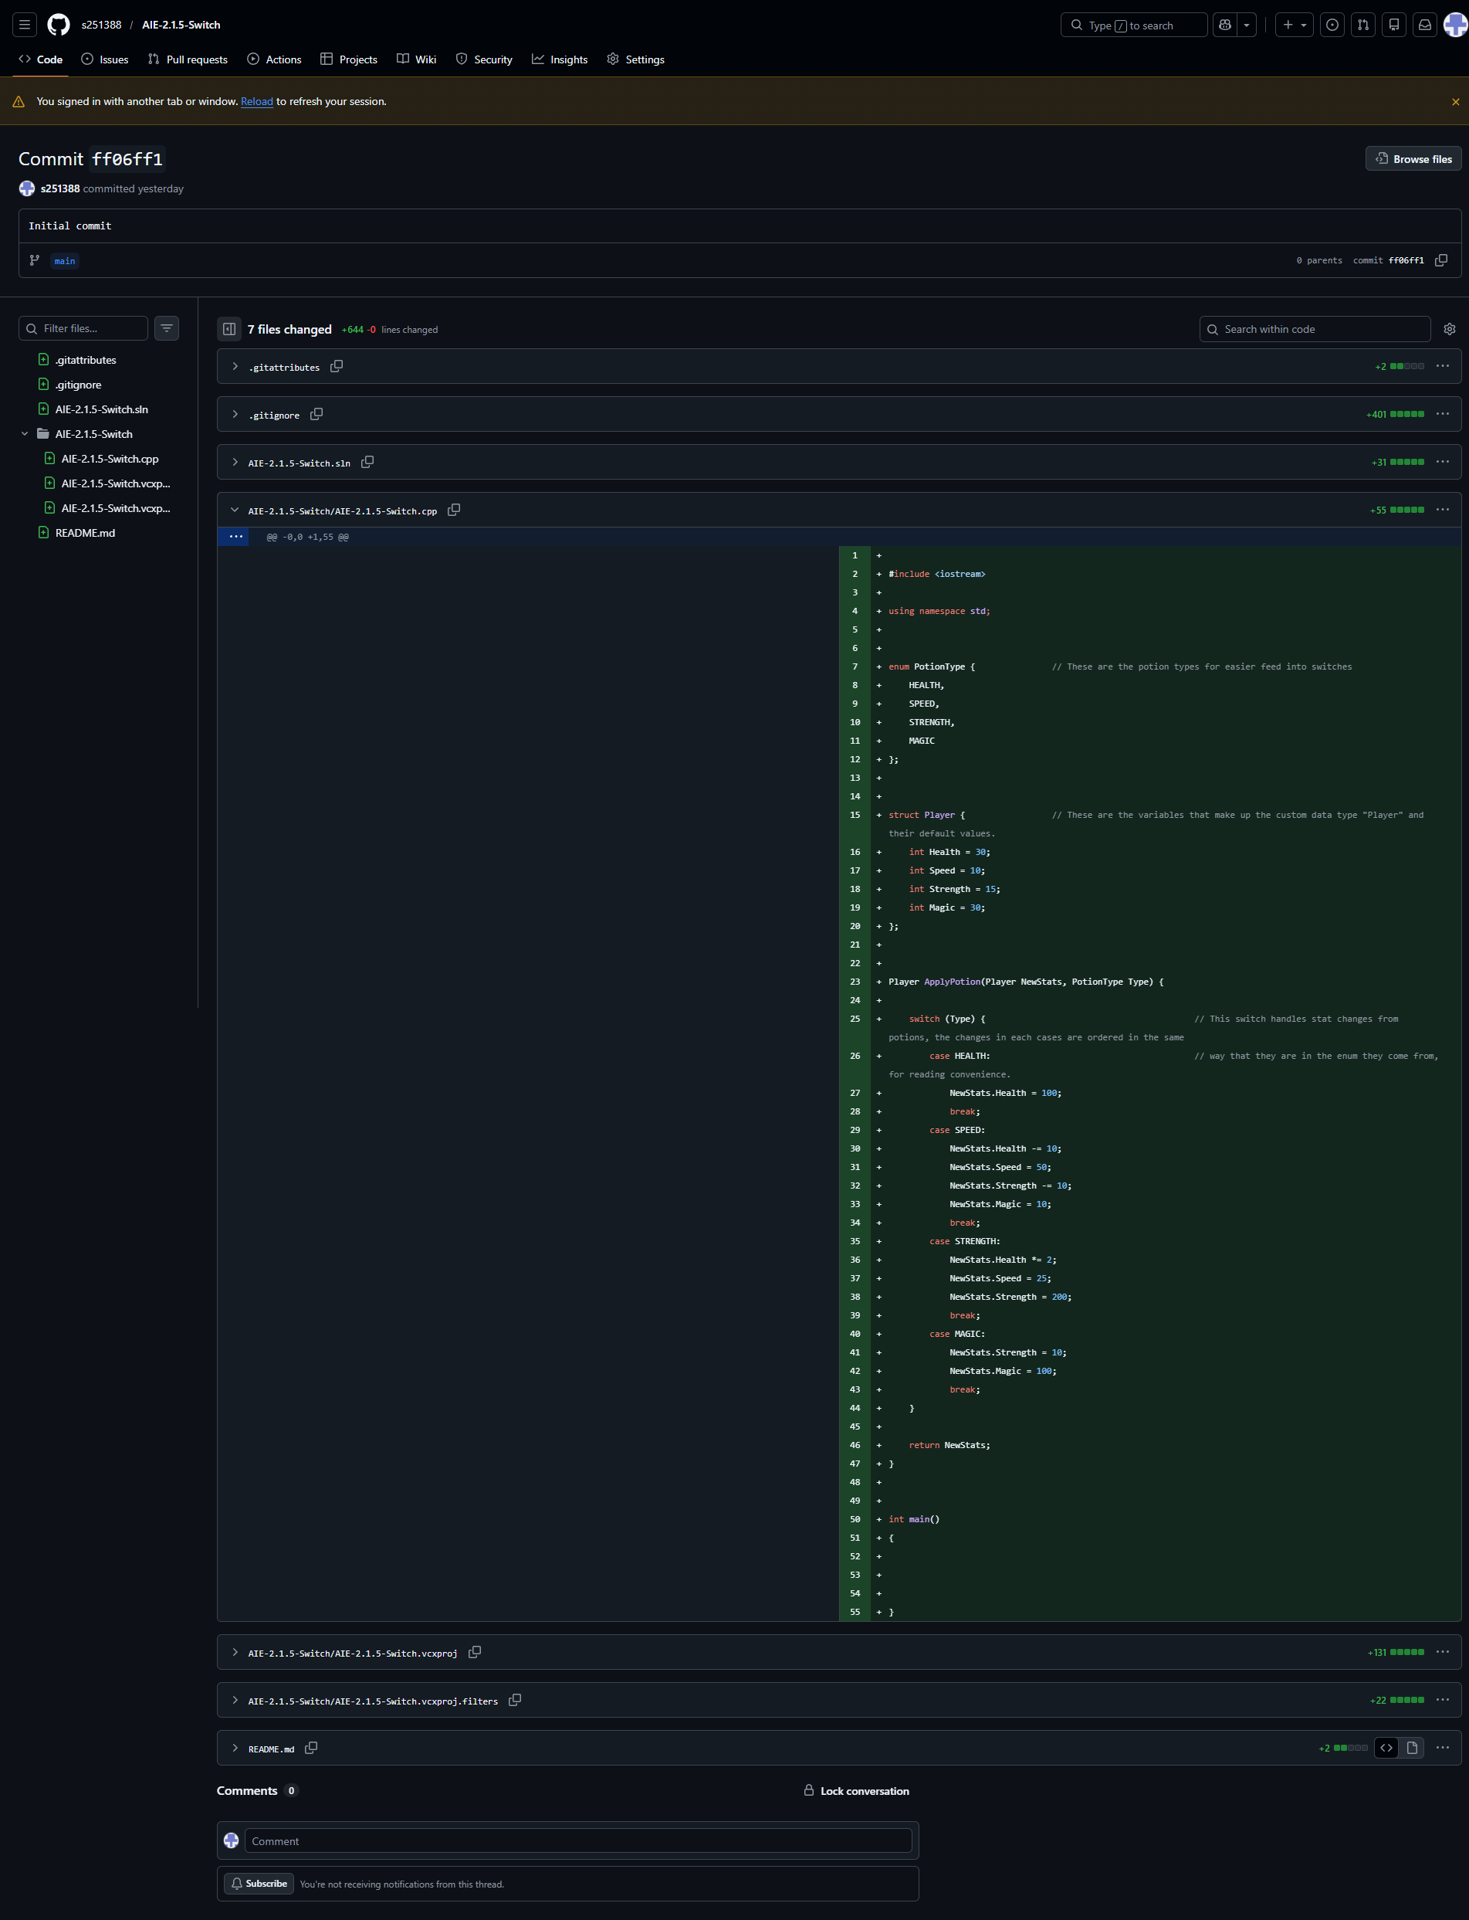
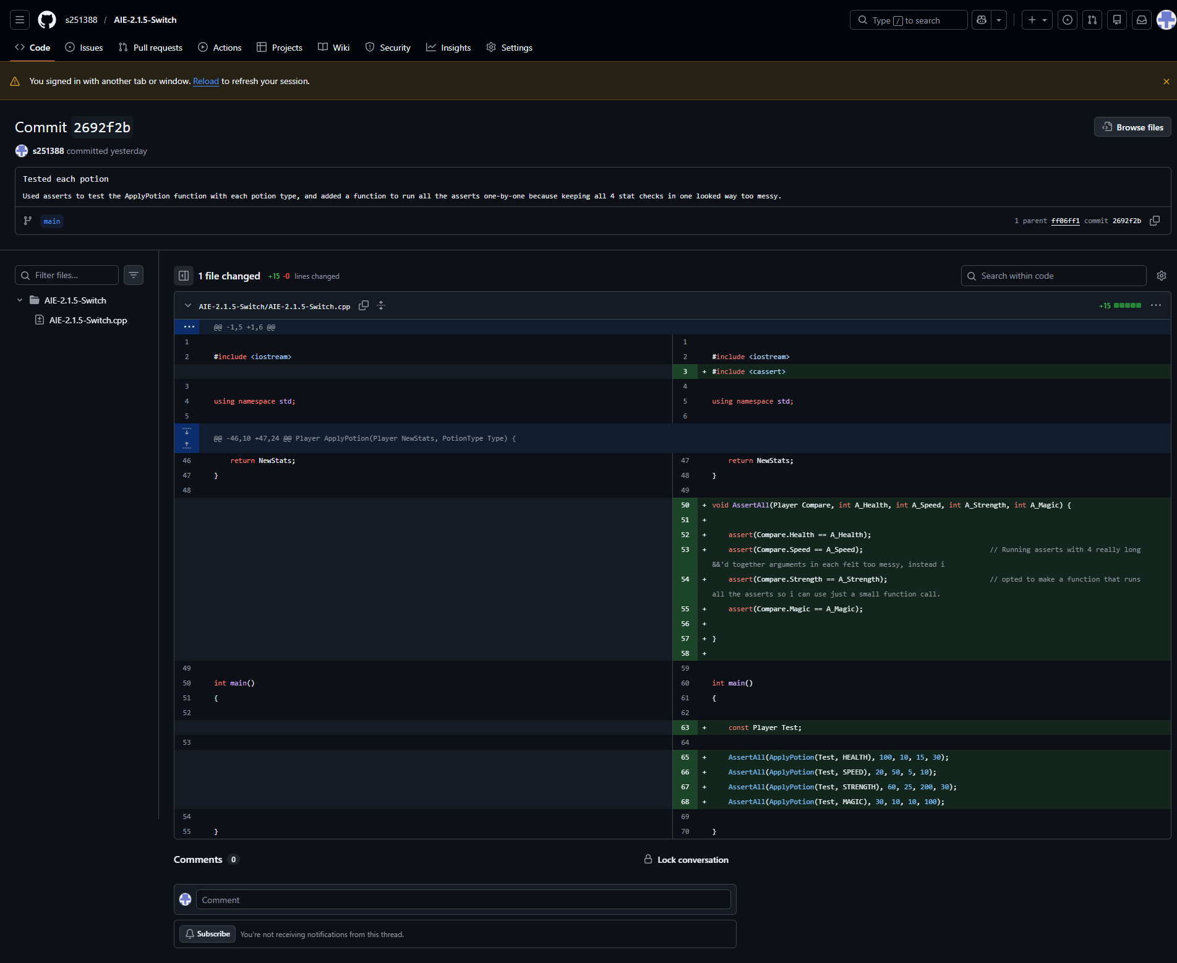

Resources:
- N/A, random knowledge from other projects
- Random information from site snippets in Google search
- Teacher in class, asking directly about issues i was having

Challenges
Write a description of the challenges, mistakes made, or problems you personally encountered, and what you did to overcome, work around, or resolve these issues. (100 - 300 words).
Had alot of trouble understanding the syntax of structs and enums, originally was using them incorrectly, treating structs and enums as if they always had to have “struct” or “enum” before using the data type’s/enum’s name. I had a big talk with my teacher about it trying to understand the syntax and what specifically i got wrong which helped me get back on track.

Weaknesses
Write a list of personal weaknesses regarding version control and ways you could resolve these weaknesses. (100 - 300 words).
I’m still having trouble fleshing out my own consistent “style” with writing code.
It’s feeling awkward sending separate commits for the function, and the testing of the function, i feel like normally these would always be committed together, i assume this is only being done for these assessment projects for educational purposes.

